Attached is a photo of my grandson, with his first ever ribbon at his first ever show. If I won the pony I would it to him, as he is now living on a property 3hrs away from us. He had a fantastic time at his first show and is very excited to compete at the Nationals in March. He loves riding and driving our horses from little horses through to draughts.

Cheers
Gary Osborne
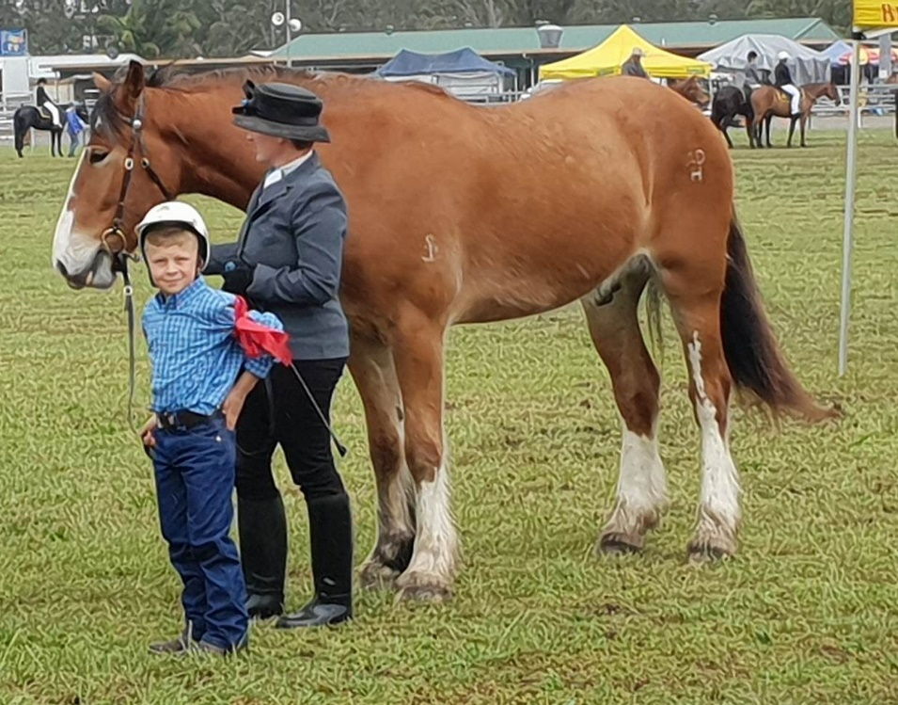
Please see attached photos.This is my step grandson warming up for the Nationals. If I won a pony I would give it to him so he could have one to call his own as he lives 3hrs away from us. As much as he loves spending time with our horses he doesn't get down often enough. He was very excited to compete at his first show last year where he won 4 ribbons and $20. Now that he lives on property I would love to see him with his own pony. Fingers crossed.

Thanks
Beatrice Osborne
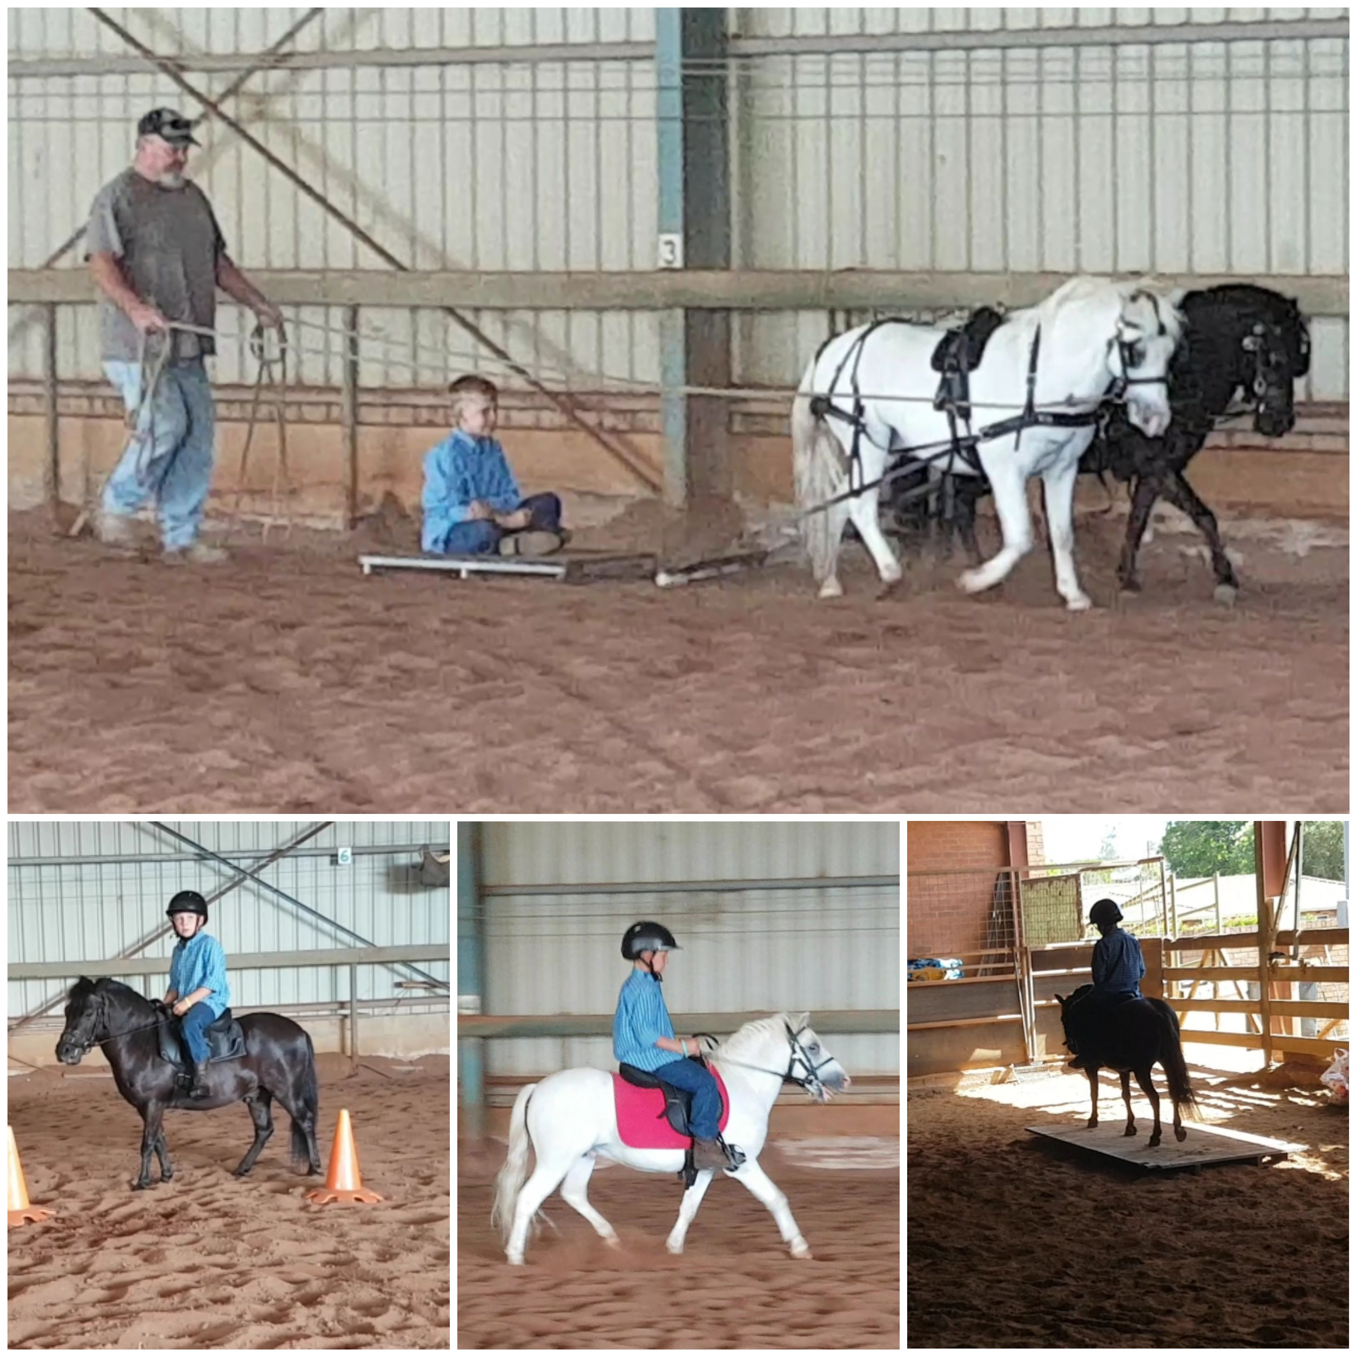
My name is Brax Kemp, I am 7 years old and can't wait for the Nationals. I would love to win a pony so I can call it my own now that I live on a farm. I loved Taree Show last year when pop let me use his horses. I won a first, two seconds, a forth and twenty dollars. It was wet but I had fun in the mud. The photos are of me at Taree show and the day after with all of my ribbons.

Thanks
Brax

